Software Design Document

“5 whys” analysis dashboard

Version 1.0

“5 whys” analysis dashboard Team:

Vibhanshu Upadhyay

Supervisor: Bindu Priya

Mentor: M S Bhanu Prakash

Rajagopalan Krishnamoorthy

Project Overview:

The primary challenge is to develop a dashboard that retreives incident data from ServiceNow or SharePoint, displays a comprehensive overiew of incidents by severity application and number, and allows detailed exploration of each incident through a “5 whys” analysis. Additionally, the system should enable app owners to enter and save lessons learned for each incident, fostering a culture of continuous improvement and knowledge sharing.

Tech Stack used:

Frontend: React JS

Backend: NodeJS

Database search: Elastic Search

API Integration: RESTful services for integrating with ServiceNow /SharePoint

Visualization tools: Chart.js, D3.js

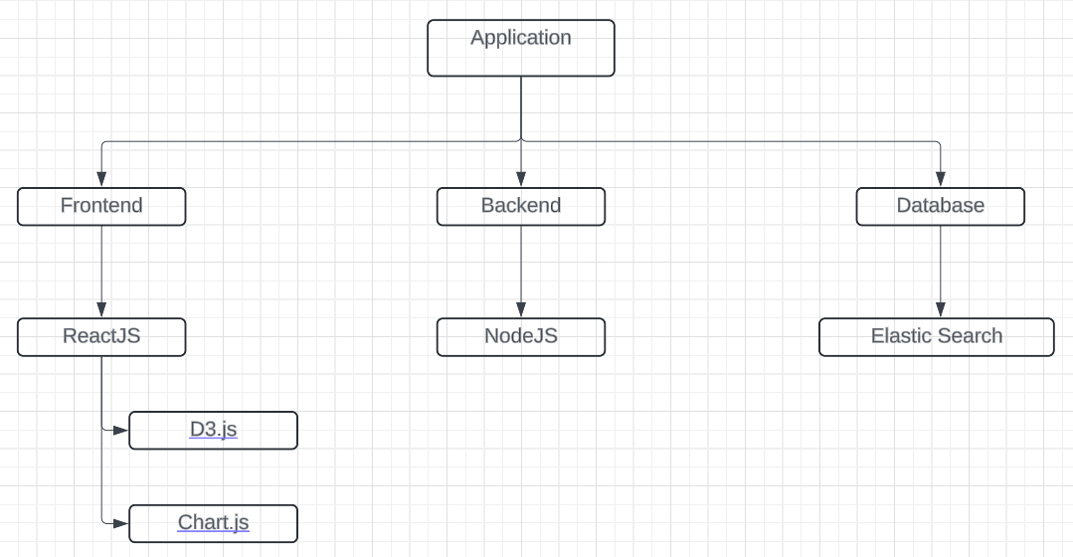Flow Diagram:

FRONTEND:

In this application, the role of the frontend is to design a dashboard that could fetch incidents from enterprise systems like ServiceNow and SharePoint, perform “5 whys” analysis on the data and finally visualize it which aids in trend analysis and decision making.

1. The fetched data is initally stored in a grid format along with attributes like Incident Id, priority and associated application.
2. Secondly, the user could click on a particular incident and perform “5 whys” analysis on it. The app owners could provide the lessons they learned after going through the analysis of the incident which could be referenced for incident resolution if the same occurs in the future.
3. Lastly, data of differenent incidents is visualized using charting libraries available for javascript.

FILE STRUCTURE:

The file structre shows how the entire application is divided into components which betters readability for the developers improving efficiency of the project.

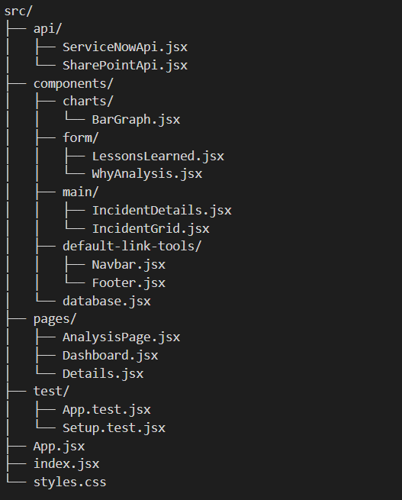

1. **api/**
   1. **ServiceNowApi.jsx:** This file contains functions for fetching incident data from the ServiceNow API.
   2. **SharePointApi.jsx:** Similar to ServiceNowApi.jsx, this file includes functions for fetching data from the SharePoint API.
2. **components/**

**2.1) charts/**

**2.1.1) BarGraph.jsx:** This file will generally contain all the visualization tools like bar graph, line chart, pie chart etc.

**2.2) form/**

**2.2.1) WhyAnalysis.jsx:** This file contains a form for conducting and documenting a "5 Why Analysis".

**2.2.2) LessonsLearned.jsx**: After entering the “5 Why analysis”, the user will enter the lessons learned in this component.

**2.3) main/**

**2.3.1) IncidentGrid.jsx:** This will be shown on the dashboard, where the fetched data is stored in the form of a grid.

**2.3.2) IncidentDetails.jsx:** After clicking on a particular incident, the user can see the entire details of that incident which is shown using this component.

**2.4) default-link-tools/**

**2.4.1) Navbar.jsx:** Basic navbar, with the ‘Wells Fargo’ logo and its colour scheme along with links to easily navigate through different pages.

**2.4.2) Footer.jsx:** Footer inspired from the wells fargo site with necessary links.

**2.5) database.jsx:** An array of objects containing the entire data of all the incidents which is used as a dummy backend until the realbackend isn’t integrated.

1. **pages/**

**3.1) Dashboard.jsx:** This is the home page, with components for displaying incident data along with its visualization.

**3.2) Details.jsx:** This page contains component for showing entire data of the dashboard.

**3.3) AnalysisPage.jsx:** This page is used for performing the “5 why analysis”.

**4) test/**

**4.1) App.test.jsx:** *For performing testing later*

**4.2) Setup.test.jsx:** *Foir performing testing later*